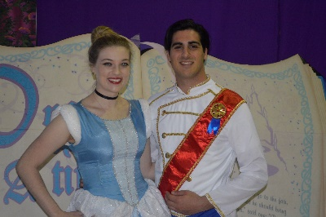
TICKET ORDER FORM

Pastries with the Princesses
Sunday, February 18, 2018 doors open 1:15pm showtime 1:30pm
Summit Art Space 140 E. Market Street Akron, OH 44308
Tickets will be at the door - reservations & payment must be paid in advance

ORDER INFO
Name __________________________________________________________
Name to put tickets in if different than buyer ______________________________

Address of buyer __________________________________________________

City _____________________ State ________ Zip ___________

Phone ___________________**Email ________________________________
**Please provide & print clearly so confirmation of order can be emailed to you.
MEDIA METHOD
How did you hear about event? ________________________________________

TICKET ORDER – Everyone, of all ages, must have a ticket to attend
Number of tickets purchased:
Adults ________________ @ $15 ____________
Children _______________ @ $15 ____________
Total # of tix ______ Total charge _______
PAYMENT METHOD – Make checks payable to The Dane Foundation.
Check _________ Mail to: The Dane Foundation PO Box 124 Cuyahoga Falls, OH 44222
Use PayPal – Button on Website
Credit Card _________ Visa MC AE DISCOVER (circle)

Credit Card # ________________________________ Exp date _________
V-code (security code) ___________________ Zip Code _________________

Name on card if different than buyer ________________________________
Full address if different than buyer___________________________________
City ____________ State_______________ Zip __________________

Email orders to: Info@TheDaneFoundation.org or mail to PO Box 124 Cuyahoga Falls, OH 44222

For office use only:
Date of order _________taken by _______________Confirmed____________ date ________________

